Living Intentionally

Finding and Living in your authentic self

Logistics Of heart centered living

https://donovancounseling.com

John Donovan, CSAC
http://www.donovancounseling.com

Living Intentionally

Personal Development

Table of Contents
Lesson 1: What I Want 1
Lesson 2: Obstacles to What I Want 2
Lesson 3: Reticular Activating System 4
SURVIVAL SIGNALS 7
Lesson 4: The Four Fundamentals of Intentional Living 9
Lesson 5: Image vs Authentic Self 10
Lesson 6: Accountability 12
THE ACCOUNTABILITY TREE 12
Lesson 7: The Issue Is Never the Issue 15
Lesson 8: The Real Issue 18
Lesson 9: De-mystifying Your Behaviors 20
Lesson 10: Love = 22
Lesson 11: Community Building 24
Lesson 12: Defining Your Authentic Self 25
Some final thoughts about living intentionally… Error! Bookmark not defined.

Lesson 1: What I Want

What is it that you want that you have never had or what you want that you had at one time and were unable to maintain or sustain? What is that for you?
I want __________________________________________________________________________
What you want, which is what you are focused on, consciously or subconsciously determines how you relate to your life. What you want or what you are focused on, determines how you hear what other people are saying to you. What you want influences your choices.
- If you do not know what you want, you will continue to get what you’ve always had.
- If you want something that you cannot have you will constantly be frustrated with yourself and others.
Consciously choosing what you want and saying it out loud starts the process of what you want coming into your experience, whatever it is that you want, it does not matter.

Examples of what you can’t have:
I want her to stop nagging.
I want to be in a relationship where both people are honest. I want her to act right.
I want people to act with common sense. I want someone to understand me

Examples of what you can have:
I want to be respectful.
I want to live a life of peace. I want to be clean and sober.
I want to be nurturing in my relationship with my wife and children. I want to live free.
I want to be honest in my relationships.

Notes:

Lesson 2: Obstacles to What I Want

Now that you have expressed what you want let’s talk about what is stopping you from getting it. Consider that what you want is something that you never have been able to acquire, or it is something that you once had and were not able to sustain and maintain.
There is an axiom that says that you have the answers inside of you. If you have the answers inside of you would you be willing to consider that what is hindering you from having what you want is also inside of you. Here is a list of the obstacles inside of you that are stopping you from having what you want.
Obstacles to what you want:
- Your Conscious/Subconscious Experiences
- Beliefs/Perceptions/Patterns
Expectations are preplanned resentments.

Your conscious/subconscious experiences become your fixed beliefs that you have about yourself that defines you in your own mind These experiences create an identity. These beliefs/thoughts left unchecked often lead to misconceptions about who we are in relation to others. These beliefs/thoughts can lead us to take what others think or say to or about us personally. What we are going to do in this class is to examine these beliefs/thoughts that we have of ourselves and consider if they are working for us. If they are working, we can keep them. If they are not working, causing us distress, discomfort we can consider letting them go.
Your perceptions/mindsets in this context are belief’s we have of ourselves that are stored in our conscious and sub-conscious mind. By definition subconscious implies that these are beliefs that are hidden, or not in our consciousness. The way we can discover these hidden beliefs is to start with what we have manifested, our current reality, and work back to discover the belief that led us to our current reality.
Your patterns are not just your physical habitual patterns, (addictive behaviors). Patterns can also be rationalizations. This can come out in statements like. “I am in jail because of a stupid mistake”. “I knew that it was wrong when I did what I did, and I did it any way”. The truth is that everybody makes the best decision that they can with the information that they have in that moment. Anything else is blame or judgment.
Your expectations are pre-planned resentments. These expectations include any expectation of yourself or others.
My personal obstacles:
- Fixed Beliefs:

- Perceptions:

- Patterns:

- Expectations:

Lesson 3: Reticular Activating System

The Reticular Activating System, (RAS) is a net like group of cells that filter out non-essential information based on where you place your focus or what it is that you are placing your attention. The only information that is able to get through this net like group of cells is information that has pay value or that is a threat. We are built, as human beings with this system of filtering information so that we are able to complete tasks.
The Reticular Activating System has enabled us to survive as a species. An example of how the RAS works is, say I am watching my favorite TV show and my wife asks me a question, I will filter out her request because my focus is on my show. Throw in a little entitlement and arrogance and I certainly will filter out her request based on my presumed authority as ‘man of the house’. A loud noise will get my attention, (threat) or I will notice the smell of toast or my favorite food because this has pay value.
Have you ever been accused of having selective hearing? Well it may be because you do have selective hearing just like everybody else on this planet. This is an example of how the brain works that has enabled us, as a species, to survive over the millennia.
Knowing that the RAS is an essential component of co-operative communication. The purpose of this part of the brain is to filter out non-essential information, it is not a personal characteristic. It is a function of the brain that has been built into every one of us. Knowing this fact will allow us to de-personalize aspects of how communication happens between you and a loved one. When we do not take personal an aspect that at face value looks like someone is either ignoring us or dismissing us, we will be better able to maintain a co-operative focus in our interactions with each other.

How We Experience

Emotions – Heart - information
Feelings – Body Sensations - Conformation
Thoughts – Cognition - Inspiration

These three information centers have been given to us as human beings for us to survive and thrive though out the process of evolution.
‘How We Experience’ Explained

Our emotions and feelings enable humans to interact within their environment in a situationally appropriate manner. The ways we take in information are listed in descending order of importance.

Emotions supply us with information vital to our safety and to our ability to relate to people, places and situations that are part of the human experience. Emotions and feelings include our interpretation of our sensory input, and as importantly, our interpretation of information that our senses are not capable of receiving.
An example of information that goes beyond our five sensory abilities might be a sense that things do not seem as they appear. A sense that there is tension in a room full of people and is not explained by what see or hear.
Feelings could be explained by saying that they are the whelming felt in our body as the emotional information is being taken in. We experience feelings or body sensations viscerally or physically. They are the conformation of the emotional information.
Thoughts are the cognition we have that reflect our interpretation of our emotions and feelings; those thoughts are our responses to what is happening in our environment. These responses enable us to interact with people, places and situations in an appropriate manner.
Here is a synopsis of what was just said:
 |  | 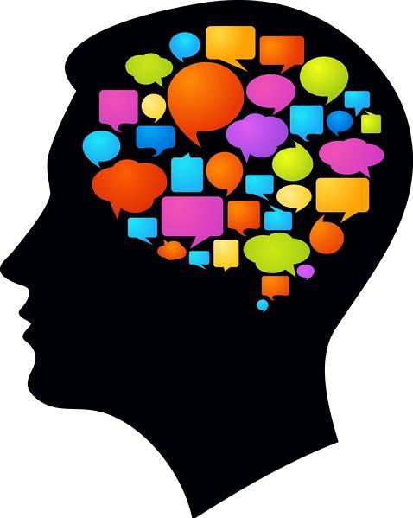
Heart  Emotions  Information | Feelings  Body Sensations Confirmation | Thoughts  Cognition  Inspiration

We have been taught in this society to deny that we have any emotions and/or feelings if we are men. We are told to be rational and logical and that emotions and feelings are signs of weakness. Women in this society can be emotional and have feelings and are demeaned and diminished for having them and seen as illogical and unreasonable. Emotions and feelings in men are denied and emotions and feelings in women are diminished.
So, we are left to navigate our relationships with the people, places and situations in our lives without our most important sources of information, our emotions and feelings. This leaves us unable to relate to each other in meaningful ways.
Thoughts (cognition) without the vital information supplied to us from our emotional and feeling bodies, are not adequate for us to successfully navigate our complex, fluid and organic relationships. Relationships are not logical nor are they rational. Relationships are workable for individuals who are connected to their emotional and feeling bodies and, then, are capable of responding in ways that are spontaneous and fluid and in alignment with what is happening.

Evolution is continuous.

Evolution has developed our ability to sense and respond to our environment in a way that allows us to survive and thrive as a species. Emotions, feelings and cognition are the three centers of information exchange enabling us as individuals to have the ability to be situationally appropriate. The information that is exchanged is the awareness of my immediate relationship to my current environment which includes people, places and things.
Here are some examples of the Reticular Activating System being informed and operating from an old paradigm and or unresolved traumas.
- Have you ever hurt someone you loved and later regretted it? And then hurt them again, usually in the same way?

- Have you ever been in an argument with someone and in the middle of it realized you were on the wrong side of the argument? But you continued to argue anyway?

- Have you ever found yourself in a situation and knew that you were about to do or say something that you would regret and heard a sometimes small voice, or sometimes loud voice in your head telling you to stop, and you found you couldn’t or wouldn’t?

SURVIVAL SIGNALS

Joy Content Afraid Anger Hurt Sad Excited Passionate
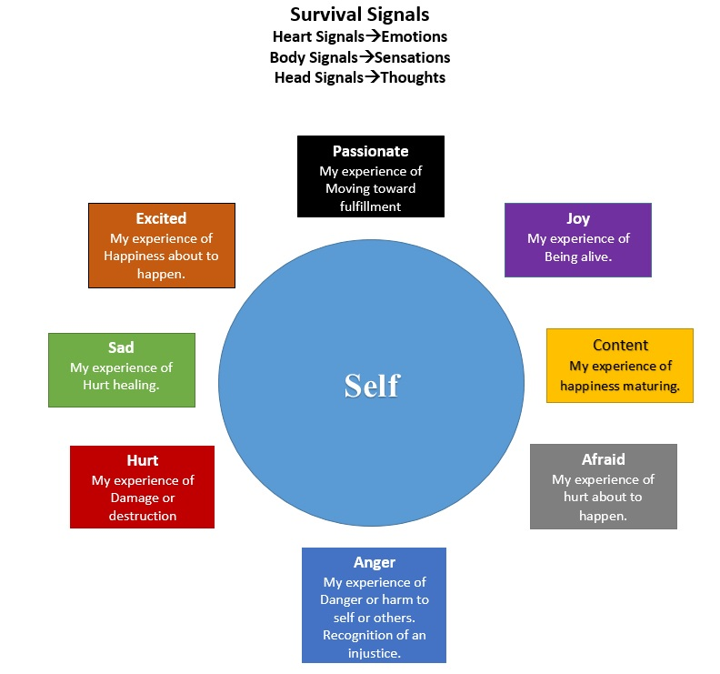

How We Experience:
Emotions: Heart - Information
Feelings: Body Sensations - Conformation
Thoughts: Cognition - Inspiration

At any given moment we are in an emotional state which consists of some combination of these emotions. This is true whether we are aware of our emotional state or we are unaware of our emotional state. Either way we are in an emotional state and that emotional state is integral with life and cannot be separated from life. We are always gathering information and assessing our relationship to our environment and our current reality.
Emotions are always neutral in that they simply convey information. Our individual perception, which is an accumulation of our individual experience, assigns value to this emotional information in the form of a judgment, (good or bad, safe or dangerous, friend or foe) onto these emotions. This information is filtered through our unique Reticular Activating System allowing us to interact with life in a timely manner and in a way that allows us to stay safe.
Our experiences, memories, are held in our conscious mind and in our subconscious mind. One eighth of our experiences are available to us in our consciousness and seven eighths of our experiences are held in our subconscious mind. All of this experience, information, is used in our decision-making process. This information is held in the form of an emotional memory. We may or may not be able to describe the details of these memories. These memories in the form of emotions influence our decision-making process.
Here is a synopsis of the decision-making process:

We make a decision based on this process, whether the information we are gathering in real time or the information that we are comparing it to from our past experiences is correct or simply our interpretation of our current reality or of our past. (Assumptions).

Lesson 4: The Four Constants of Relationships.

The process of acquiring, maintaining and sustaining what you want.
- Focus – attention
- Own my projections
- Move toward my pain
- Today I intend to…
These concepts will be used in each and every discussion. They are fundamental to co-operative communication. They will assist in bringing clarity to our behaviors. Here is a brief description of the four fundamentals:
Focus-Attention
Your focus, or what you are paying attention to, determines how you see, hear, perceive your world and the people, places and things in it. Your perceptions and beliefs filter your understanding of your circumstances.
You filter information that comes into you through what and where you place your attention. One eighth of your experiences are conscious and seven eighths of your experiences are held in your subconscious. Eight eighths of your experiences are used to make decisions in your current reality. Paying attention to what you focus on is the beginning of your awareness that you have influence over what ultimately happens to you.
Own My Projections:
What you see in other people is not who they are; what you see in them is who you are. This can be very confusing to you. Not being aware of this is the reason for your inability to maintain peace of mind.
Move toward My Pain:
When you are moving toward your pain, or staying with/in your pain and discomfort, you are gaining wisdom. When you avoid your pain or discomfort you are stuffing your emotions and feelings; you are losing an opportunity to gain wisdom.
Today I Intend To:
If you did not make a conscious intention for today or for this moment, you are being motivated by experiences, sometimes painful experiences, (trauma) from your past.

Lesson 5: Image vs Authentic Self

Because of the nature of how we have been raised, many of us have developed a false sense of self. To be a man in this society we have been expected to act in a certain way. We were expected to be tough and don’t cry, not to be emotional. Here are some expectations and beliefs about men that have been propagated by our society. From these expectations we have developed a false self, ‘Masculine Identity’. This is an image, (role) that has been assumed to be who we are as individuals. “Man of the house”, “Provider”, “Husband” and we have identified with the role and lost our Authentic Selves.

We are taken advantage of because we need our jobs.
We hurt the people we love and regret it afterwards.
We are valued by how much money we earn.
We are denied our feelings, (tears, laughter, trembling, talking, yawning) and thus the healing process.
We are expendable, (women and children first).
We are treated as inherently compulsive in our sexuality.
We are told that males are aggressive and violent by nature.
We are told to be tough and don’t cry.
We are treated differently than females.
We are expected to kill for country and family.
We are denied the healing process, thereby carrying all the hurts from childhood to present.
We are taught not to act as if we feel anything deeply.
We are trained to feel responsible for everything.
We were sexually abused.
We are burdened with unreasonable expectations.
We are seen as inhuman.
We are kept apart from our children.
We are seen as weak if we ask for help.
Adapted from the, “Seattle Men’s Group”.

Women have been diminished, demeaned, and hindered from being authentic in a similar manner.
- Women are seen as weak
- Women are emotional
- Women are less than
- Ever flowing breast
- Barbie doll
- Women are objects
- Women are property
- Women started this whole thing by eating the apple
- Women are not seen as equal.

From these expectations we have developed a false self, ‘Feminine Identity’. This is an image, (role) that has been assumed to be who we are as individuals. “Woman of the house”, “Housewife”, “Barbie Doll”, “Ever flowing Breast”, and we have identified with the role and lost our Authentic Selves.

Both men and women have taken on roles dictated by the societal expectations. These roles have been internalized and we have identified ourselves as these roles. We have lost our sense of self as the unique and vital beings that we are. This has restricted our ability to feel our intrinsic value and know that who we are is our unique contribution to others and that value emanates from within us. We have attached our value to what we do and detached that value from who we are. We have become ‘human doings’ and not ‘human beings’.
We filter the information coming to us through our role. The ‘Role’ is a construct of who we are and is riddled with expectations. This creates people who feel empty, lost, resentful, bitter and contemptuous while not being able to figure out why or how.
A way out!!
Who Am I?
Where Am I?
What Do I Want?
Knowing the response to these questions establishes us in the present moment!
For the exercise to find out ‘who’ you are, go to Session 12.

Lesson 6: Accountability

Accountable: adjective
- Subject to the obligation to report, explain or justify something. Responsible, answerable.
- Capable of being explained, explicable, explainable.
Accountability: noun
- The state of being accountable, liable or answerable.

Accountability as defined in this class.
- Stating the data about my behaviors, without blame or judgment.
- Stating the data about my participation in relationship to people, places, or things.
- Accountability is my ability to state the truth about my behaviors without blame or judgment.

THE ACCOUNTABILITY TREE

I refer to the diagram below, and on the following page as the “Accountability Tree”.
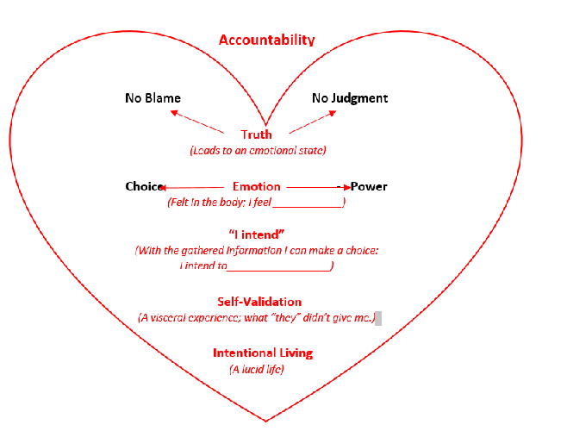

The diagram is the center piece of this workbook. It is the action taken that begins the process of ‘letting go’ of old patterns that are no longer useful. When you are able to name the behaviors that have perplexed you with their irrationality and sometimes destructiveness without blame or judgment and allow the emotions and feelings to whelm, you are able to redirect your intent, (focus) and find that you are now acting or responding in a different way. You are then able to have the compassion and validation that, I will say, I wanted from others and was never able to get and it is coming from a source that I had not expected, it to come from, myself.

Accountability Tree

No Blame No Judgment

My Truth
(Leads to an emotional state)

Choice Emotion - Power

(Felt in the body; I feel ____________)

“I intend”
(With the gathered information I can make a choice:
I intend to__________________)

Self-Validation
(A visceral experience; what “they” didn’t give me.)

Living Intentionally
(A lucid life)

An example of how this works:

ACCOUNTABILITY: When I am able to state my truth without blame or judgment, that truth resonates throughout my body.

TRUTH: Hi, my name is John and I am an alcoholic! (You can substitute any behavior or trait that is your truth and do this process ad-nausea. I am arrogant, I am entitled, I am mean, I am a bigot, I am a classist, I procrastinate, I am a bad father)
This statement of my truth activates an emotion, a feeling that gathers information that is pertinent to the statement.

EMOTION: The gathering of information, past and present.
That information is assimilated and evaluated and affords me the resolution, (clarity) I need in that moment to afford me options that are specific to the statement.

I INTEND: I now have a direction because I have accepted the present moment.
I want to come back to this or another meeting.
Aaaaaahhhhh!!!
SELF-VALIDATION: A feeling of relief, belonging, peace???

Living Intentionally: I have just gone from ‘reactor’ to ‘actor.’

Lesson 7: The Issue Is Never the Issue

Motivation behind destructive behavior.
Have you ever found yourself arguing about the same issue over and over with someone, but you never seem to find any resolution to that argument? If so, that means that whatever you are arguing about is not the underlining cause of the argument. When you do find the underlining cause of your argument you can find some resolution and clarity and have some peace in your relationship.
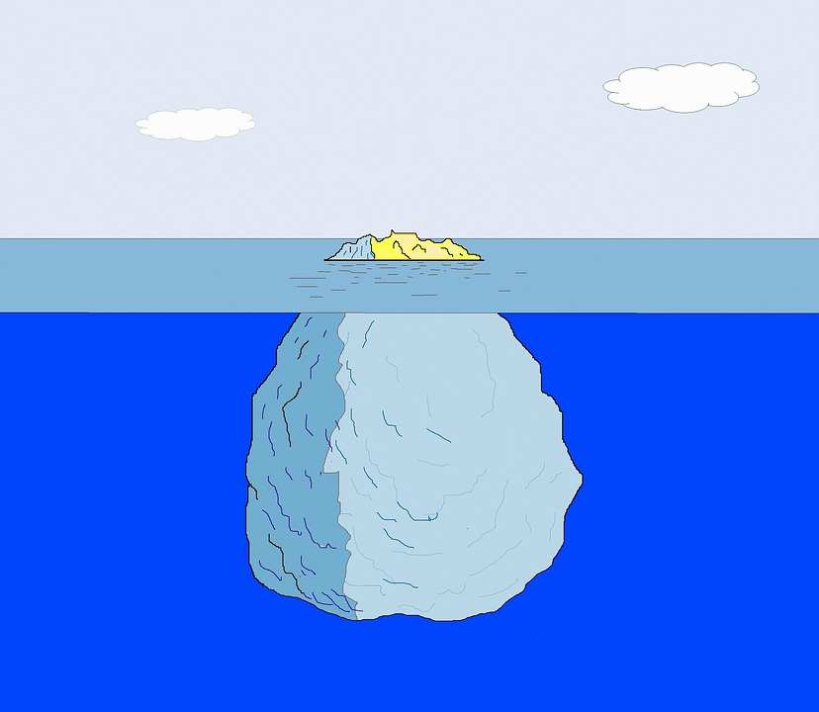
Subconscious Mind MindMiM=Mind
Conscious Mind
7/8
1/8
Drawing from Pixaby—Creative Commons

Our experiences are held in our memories. These memories could be described as the pool of information accumulated to enable us to survive in our current situations/circumstances. Our memories are created by our experience and equivalent feeling/emotion that we have associated with that experience. One eighth of our experiences are held in our conscious memories. We have the power to reframe these memories, to use rational, deductive reasoning and emotive expression, as in the case of a trauma, to process and heal. Reframing can be described as a new consciousness about how to express, feel and move to resolution. To be “Proactive”. Seven eighths of our experiences are held in our subconscious memories, meaning that these experiences/memories are not available to our conscious, rational, deductive reasoning or emotive expression. The memories held in our subconscious are inductive, non-rational, and not open to interpretation. They fall in the realm of “reactive.” They have been incorporated into our fixed beliefs. To reframe (process, heal) these memories, necessarily they need to be brought to our consciousness. Based on the definition of subconscious they are not available to our consciousness. Although active in our decision-making processes, we remain unaware of these motivating experiences/memories. These subconscious experiences/memories contribute to the phenomenon of “why do I do what I do not want to do”.

Eight eighths of our memories are engaged in the process of decision making. Each situation/circumstance that we find ourselves in we are directed, like or not, by the totality of our acquired experiences. Our conscious and subconscious memories contribute to each decision.

We have the innate capacity to accumulate experiences that are embodied ensuring our survival as a species.

In this workbook you will be given a process that will enable you to bring your subconscious experiences (trauma) into the conscious realm and facilitate healing.

(What and where our memories are stored has not been agreed on and is a controversial issue. I will leave that determination up to the experts. I believe that the description above gives me a working model for my healing. It is certainly not a comprehensive scientific study nor am I an expert on the subject. Take what fits for you and leave the rest. Or better yet, do your own study and come to your own conclusions. This works for me.)

We hold one eighth of our experience in our conscious mind. Seven eighths of our experience is held in our subconscious mind. Eight eighths of our experiences motivate our behaviors. By “subconscious,” I mean the experiences in my life that have been relegated to my subconscious memories and are still motivating my behaviors.

Beginning to find resolution to my relational dilemmas is in the ownership of these underlining, ‘subconscious’ motivations for my behaviors.
We can identify our motivating experiences, (trauma) by identifying and owning the results, current reality.
This process usually starts with owning our character defects.
Which of these character defects are true for you?
Arrogant – Entitled – Mean - Controlling - Needy
These and many more of my character defects are the end results of my accumulated memories motivating my choices… My behaviors. When I am not aware of these defects and/or do not take ownership of them, I am left with the impression that my behaviors are the direct result of something that the other person has done or is doing. Then I will do one of three things in order to make some kind of sense of these behaviors:
- Deny my behaviors outright
- Blame circumstances for my behaviors
- Minimize my behaviors
This is the irrational part behind the never-ending argument that I found myself having in my relationships.
‘The first argument I had with the person I was in relationship with usually was the last argument I had with her when the door hit me in the ass.’

Lesson 8: The Real Issue
Resentment, bitterness and contempt are at the seat of our motivation for destructive behaviors.
Violence is a behavior; anger is an experience.
We do not choose anger: it happens to us as a healthy response to our environment. To describe a violent behavior as anger is misleading. It implies that anger is something that needs to be controlled.
Our choice to be violent is a response to a perceived threat, real or imagined. The threat that is responded to is usually not something that is in the present moment. It comes from unresolved traumas that are projected into and mixed up with our current reality.
The motivation for violence is coming out of our past experiences and appears, at times irrational to ourselves and to others. To explain these violent behaviors, we come up with anything that can help us justify these same irrational behaviors.
Saying that we were angry somehow makes sense. Although it is not true, the truth is that we project our resentment, bitterness and contempt of past traumas onto whoever is standing in front of us and blame them, or circumstances, as the cause of our violent behavior.
Here is an explanation of what happens to men and women in our society:

- Men are told that emotions are for girls and women.
- Emotions in women are seen as a weakness and so are demeaned.
- In our attempt to suppress our emotions we necessarily have to deny, blame or minimize these emotions in order to uphold the image we are supposed to maintain as adult, men/women.

This process usually begins at the age of three or even earlier.
Men are told not to cry. If we do, we can expect criticism and humiliation from our guardians and then’ later, from our peers.
Women are expected to cry, and are then seen as inferior because they express their emotions.
The price for not feeling our emotion is the loss of our emotional processes and thus our ability to connect to ourselves and to others. This relegates us to a life cut off from the people we say that we love.
The healing process is linked to our ability to process our emotions and verbalize our wants and needs. We need to express our emotions in order to ensure our emotional health. The ability to express our emotions is the process that was taken from men and that has been diminished and demeaned for women.
We hold one eighth of our experience in our conscious mind. Seven eighths of our experience is held in our subconscious mind. Eight eighths of our experiences motivate our behaviors.
The experiences that we have are linked to emotions and these emotional memories are triggered when we find ourselves in stressful situations, real or imagined. Many of these memories are usually of things that we experienced when we were mistreated or traumatized as children. They were then suppressed, or relegated to our subconscious mind and thus are hidden from us. Many of these memories are our experiences of pain and discomfort. Some of these memories are pre-verbal and we do not have the words, (vocabulary) to describe them.
What happens when traumas are unresolved?

These unhealed, physical, verbal and emotional experiences are stuffed and are expressed as resentment, bitterness and contempt.

If as children we did not have someone to help us process these feelings, we were compelled to hide and stuff them in order to survive. When we are not able to heal our trauma’s, we will then be compelled to transmit them.

Lesson 9: De-mystifying Your Behaviors

We are not our behaviors.
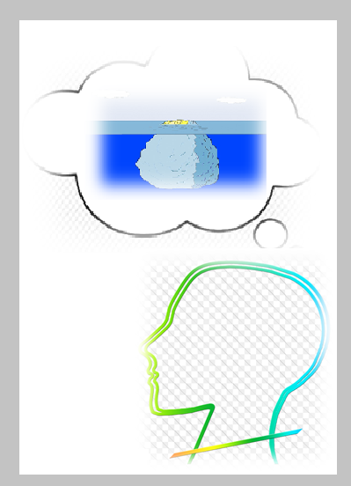
Behaviors are motivated by beliefs and perceptions. Everything we do, the motivation to do it comes from inside of us. Our experience as human beings is held in our consciousness. One eighth of our experiences are conscious and seven eighths of our experiences are ‘sub’ conscious. Our conscious and subconscious experiences blend to create the motivating factors contributing to and informing our behaviors. They form our beliefs.

When we are accountable for our behaviors, we begin the process of uncovering the hidden (subconscious) experiences and beliefs. Behaviors that seem unreasonable become reasonable in the light of our hidden beliefs that have been held since childhood and have been secretly motivating our behaviors.

The process of accountability outlined in Lesson 6 offers a way to uncover and move through our subconscious beliefs that are our hidden motivating factors contributing to our sometimes-irrational behaviors. When we find ourselves in reoccurring situations that are harmful, awkward and stressful, having the ability to recognize our internal motivations and know that we are contributing to the discomfort enables us to find relief.

When we have the understanding that we are always contributing to the outcome of relational situations (which are the results we create based on our internal motivating beliefs) we have the awareness needed to affect a change in our behaviors. When we acquire this level of accountability, we will have the ability to respond to others in a way that creates connection and intimacy.

What we are talking about here is having the ability to be introspective.

Example: Have you ever hurt someone that you loved and regretted it and then hurt them again, usually in the same way?

This pattern and other destructive patterns that we find ourselves in are the result of beliefs that have been relegated to our subconscious memories and are the contributing factors to our unwanted behaviors.

Beliefs, conscious and subconscious, create neuropathways in our brain. These pathways become habitual and in turn substantiate our held beliefs. Theses habitual beliefs have facilitated our ability to survive and stay with us way past their usefulness and have become habits and patterns that now keep us stuck in old behaviors.
Our brain has a mechanism in place to safeguard our beliefs whether they are working in our best interest or not. That safety system is called ‘The Reticular Activating System.’ This RAS is a net-like group of cells that filter out non-essential information that does not align with our beliefs. The RAS task is to maintain and sustain the belief system that we've developed to keep us safe and out of harm’s way.
An example of this is that if I believe that men are smarter than women, I will filter out any information to the contrary. I will only allow the information that substantiates this belief into my consciousness. It does not matter whether the information or the belief is the correct information or belief or not: the RAS filters just the same. The RAS is subjective, inductive not deductive. If new information is introduced that does not align with the old belief or information, it is simply discarded as non-essential information.

This explains why it is sometimes difficult to change our habits. In order to change we must challenge our survival mechanism!

This survival mechanism that has allowed us to survive for millions of years has been hijacked and is now in service to a belief system that is riddled with lies and misinformation. Our survival mechanism is subjective and does not equivocate. It simply believes what you tell it. If our experience has been that the people who tell us they love us are the same people that hurt and traumatize us it is difficult at best, impossible at worst, to create a loving, caring, nurturing relationship. We have instilled into our core neural mechanism: Love = Pain.

Being aware of the Reticular Activating System (RAS) is essential to our ability to relate and communicate with others.

Lesson 10: Love =
This exercise consists of discovering how you manifest love. How you understand at a deep level, what love means.
Your beliefs, manifest in action and attitude.
If this statement is true than you can start where you are, current reality, and back track to the originating belief or intent, which has created your current situation.
When asked, “What is love”, people will respond with what they believe to be true of love. Some of the typical responses are: unconditional, persevering, kind, caring, giving, and forgiving.
This exercise is an excursion into a place that few people are able to go into our subconscious. I believe that all people would chose to go if given the information on how to proceed.
The question is not; “Can I love?” The question is “How do I love”?

We cannot not love!!!
We love according to our awareness and consciousness.
We are manifesting love, but we have gotten love mixed up with something other than love.

Universal Fears
- Abandonment/Separation
- Worthlessness
- Surrender/Trust
Which one of these words resonates with you?
Think back on how you were loved, by your father and by your mother. How were you treated by your primary caretakers?
How they treated you, through their filters: this is how you came to see love.
One of these words from the list of universal fears may fit for you. If not words like rejection, fear, pain, or self-hate will resonate. Words like these will take you straight back to one of the universal fears. If the word ‘rejection’ resonates with you, that will work for the purpose of this exercise.

When you have discovered how you see love, your whole life will make sense to you. Every decision you have ever made will make sense to you, based on how you experienced love. Now create an intent to change how you wish to experience love.
I intend to see love as acceptance, trustworthiness, compassion, honesty, etc...

Love = Rejection RRejectionrejection
Changes to… to…..
Love = Acceptance

Lesson 11: Community Building
Discuss how having a supportive community of like-minded people will enable you to transition to a free and stable life.
Discuss resources that are available to you in the community in which they live.
Talk about how their old beliefs have hindered their ability to ask for help, assistance from their loved ones and community.
Discuss how the concept of ‘being in service to others’ is a necessary part of a healthy, vital life.
Discuss the concept, ‘Give that you wish to receive’. Discuss the topic of re-unification.
When the gate hits me in the ass, I will ?

Lesson 12: Defining Your Authentic Self

Use the essence words sheet and pick three words that describes your essence or three words that you feel that in no way are qualities that you possess. Put them in the sentence, ‘I am a ___________________________, _________________________, _____________________ man/woman.

ESSENCE WORDS

Loving  Forgiving  Trusting  Empowering  Willing  Nurturing  Caring  Giving  Trustworthy  Courageous  Gracious  Spontaneous | Humorous  Powerful  Grateful  Beautiful  Peaceful  Open  Kind  Humble  Compassionate  Worthy  Confident  Genuine | Gentle  Spiritual  Honest  Passionate  Wise  Creative  Authentic  Free  Tenacious  Whole  Pure  Radiant

Statement of Intent

Create a statement of Intent, using the format below.

- Through my…..

- It is my intent to….

- Creating a world of ….

Through myRefers to the assets that the person brings to his purpose, such as;

Through my open, gentle, loving nature…
Through my gracious, creative, genuine spirit…

It is my intent to Refers to something the person loves or hates. This is what the person usually pays attention to, and/or, is drawn to.

It is my intent to teach, heal, unify, and serve, by being who I am…
It is my intent to walk with an open courageous heart, mentoring inner strength…

Creating a world ofRefers to the type of world the person wants to live in. The qualities of this world could come from the person’s wounding. What was the significant hurt or re-occurring issue in the person’s life? What do they want instead?

Creating a world of acceptance, harmony and unity.
Creating a world of nurturing, loving beings.
Creating a world of unconditional love and acceptance.

Examples of purpose statements:
- Through my open, gentle, loving nature,
- It is my intent to teach, heal, unify, and serve, by being who I am.
- Creating a world of acceptance, harmony and unity.
Or:
- Through my gracious, creative, genuine spirit.
- It is my intent to walk with an open courageous heart, mentoring inner strength.
- Creating a world of nurturing, loving beings.

